Kruskal Wallis test in R, Kruskal Wallis test is one of the frequently used methods in nonparametric statistics for analyzing data in one-way classification.

It is equivalent to a one-way analysis of variance in parametric methods.

When we test the identicalness of the k population from which the independent samples have been drawn. There is no restriction of sample sizes.

**Assumptions**

Mainly Kruskal Wallis test is based on the following assumptions.

1. The observations are independent within and between samples.
2. The variable under study is continuous
3. The populations are identical in respect to the median.

**Hypothesis**

Ho: All the populations are identical

H1: At least one pair of the population do not have the same median.

The test statistic is approximately distributed as chi-square with (k-1) degrees of freedom. , subject to the condition n should be large or at least n should not be less than 5.

**Kruskal Wallis test in R**

**Load Package**

library(tidyverse)

library(ggpubr)

library(rstatix)

**Getting Data**

set.seed(345)

PlantGrowth %>% sample_n_by(group, size = 1)

Output:-

weight group

1 5.18 ctrl

2 4.41 trt1

3 5.26 trt2

Ordering the group is really important when you are doing Duncan’s multiple comparison tests.

PlantGrowth <- PlantGrowth %>%

  reorder_levels(group, order = c("ctrl", "trt1", "trt2"))

**Summary**

PlantGrowth %>%

group_by(group) %>%

  get_summary_stats(weight, type = "common")

Output:-

group variable n min max median iqr mean sd se ci

1 ctrl weight 10 4.17 6.11 5.155 0.743 5.032 0.583 0.184 0.417

2 trt1 weight 10 3.59 6.03 4.550 0.662 4.661 0.794 0.251 0.568

3 trt2 weight 10 4.92 6.31 5.435 0.467 5.526 0.443 0.140 0.317

**Visualization**

ggboxplot(PlantGrowth, x = "group", y = "weight", fill="group")

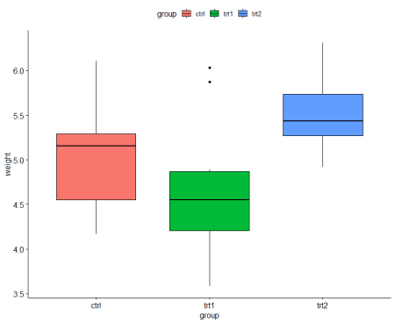

Based on the box plot, it evident that some difference exist between treatment 1 and treatment 2.

**Kruskal Wallis Test**

res.kruskal <- PlantGrowth %>% kruskal_test(weight ~ group)

res.kruskal

Output:-

.y. n statistic df p method

1 weight 30 7.988229 2 0.0184 Kruskal-Wallis

Based on the p-value significant difference was observed between the group pairs.

**Effect size**

The effect size values normally interpreted as 0.01- < 0.06 (small effect), 0.06 – < 0.14 (moderate effect) and >= 0.14 (large effect).

PlantGrowth %>% kruskal_effsize(weight ~ group)

     .y.  n   effsize  method magnitude

1 weight 30 0.2217862 eta2[H]     large

If effect size is large easily we can identify the significant differences based on small number of sample sizee.

**Pairwise comparisons**

Based on the Kruskal Wallis test we identified a significant difference, but we don’t which pair is significantly different. A pairwise comparison will help us to identify the significant pair.

res1<- PlantGrowth %>%

  dunn_test(weight ~ group, p.adjust.method = "bonferroni")

res1

Output:-

.y. group1 group2 n1 n2 statistic          p      p.adj p.adj.signif

1 weight   ctrl   trt1 10 10 -1.117725 0.26368427 0.79105280           ns

2 weight   ctrl   trt2 10 10  1.689290 0.09116394 0.27349183           ns

3 weight   trt1   trt2 10 10  2.807015 0.00500029 0.01500087            *

Based on the pairwise comparison significant difference was observed between Treatment and Traetment2.

res2 <- PlantGrowth %>%

wilcox_test(weight ~ group, p.adjust.method = "bonferroni")

res2

.y. group1 group2 n1 n2 statistic     p p.adj p.adj.signif

1 weight   ctrl   trt1 10 10      67.5 0.199 0.597           ns

2 weight   ctrl   trt2 10 10      25.0 0.063 0.189           ns

3 weight   trt1   trt2 10 10      16.0 0.009 0.027            *

Based on Wilcoxon test also significant difference was observed between treatment 1 and treatment 2.

**Visualization with p-values** 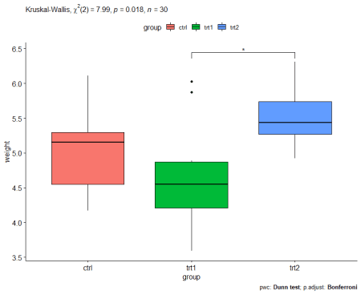

res1 <- res1 %>% add_xy_position(x = "group")

ggboxplot(PlantGrowth, x = "group", y = "weight") +

  stat_pvalue_manual(res1, hide.ns = TRUE) +

  labs(

    subtitle = get_test_label(res.kruskal, detailed = TRUE),

    caption = get_pwc_label(res1))

**Conclusion**

Kruskal-Wallis test is an alternative to the one-way ANOVA when there are more than two groups to compare.

When ANOVA assumptions are not met It’s recommended.